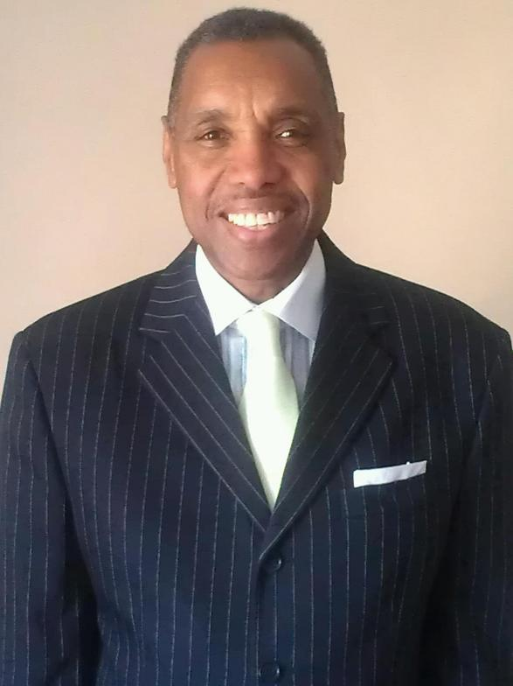

Feed the City is a successful non-profit organization providing many community programs and has been feeding the city since 2006. They feed the public daily Monday-Saturday from 12 noon to 3:00p.m. Feed The City serves over 400 families with Thanksgiving Turkey Giveaways Annually. Also there’s a clothing closet, and emergency food boxes for families in their time of crisis. Warm a Heart coat drive provides new coats for kids K-12 annually during Christmas. Operation Help is a combination of a health care fare and we also provide a truck load of food & clothing to the community. Back to School Supply Giveaways provide backpacks and supplies to youth K-12 returning to school. There’s a program for rehabilitating men and women coming out of prison. In 2009 the Lord spoke to Pastor Coleman on a 21 day fast about passing out bibles to murder victims, the sick and shut in, inmates in prison, new marriages, newborn babies entering into the world and those in desperate situations. Many volunteers help with these events, allowing the Kingdom work of God to be done as we serve one another.
Pastor Larry D. Coleman attended Southern Baptist Boyce Bible College for four years. He severed on the board of Prodigal Ministries as Program Coordinator; he also served on staff as an ordained Minister with the Evangel World Prayer. Pastor Coleman was the Executive Director of the Lords Kitchen and founded the prison ministry called Reconciliation Ministries. He is also the Founder and President of City Church Inc. and Feed the City, a non-profit organization where we assist with food, clothing & every day needs. Pastor Larry D. Coleman is devoted to his wife and children.

We are our Brothers’ & Sisters’ keeper!

